Michael Osei

4/5/23

COSC 480

Week 8 SQL Screenshots

Applying Sql Script

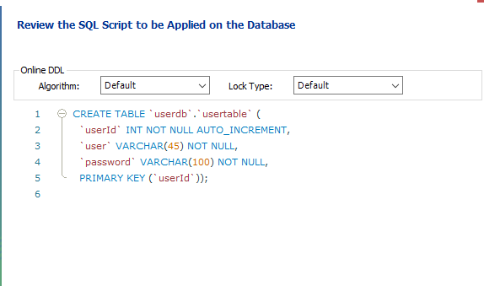

Making user account

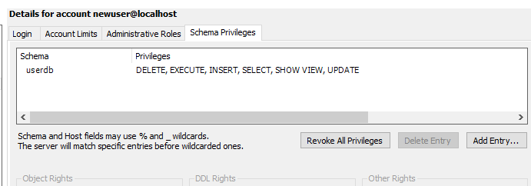

Connected to mySQL DB



Files that were in db-practice1

